Vanessa Grossman

**Arquitetura Nova [New Architecture], São Paulo, Brazil**

Ferro, Sérgio (1938–); Império, Flávio (1935–1985); Lefèvre, Rodrigo (1938–1984)

**Thumbnail**

When the architect Sérgio Ferro entitled his 1967 manifesto “New Architecture” [1] he proclaimed a new architecture in Brazil by means of alignment with the thesis-manifesto “An Aesthetic of Hunger” written by the Brazilian filmmaker Glauber Rocha, and first published two years earlier.[2] According to Ferro, Arquitetura Nova was a clear reference to Rocha’s “New Cinema”: films made from “simple means and ideas in mind.” [3]

Together with architects Flávio Império and Rodrigo Lefèvre Ferro took Cinema Novo’s “neo-realist” approach as far as it could reasonably be applied to architecture. They designated it as a new “poetics of economy,” that should be defined from “the useful minimum”, the “constructive minimum” and from the “didactic minimum” for the formulation of a new language established “on the basis of Brazil’s historical reality.”[4] In their texts and projects, developed throughout the 1960s, they advocated not only the use of popular materials and techniques, in order to make architecture more accessible to the masses, but also the means by which the constructive process would be intelligible for all the protagonists involved. Despite the 1967 manifesto, written three years after Brazil’s coup d’état, Ferro only retrospectively referred to the group’s experience as Arquitetura Nova, in 1988.[5]

**Full Entry**

When the architect Sérgio Ferro entitled his 1967 manifesto “New Architecture” [6] he proclaimed a new architecture in Brazil by means of alignment with the thesis-manifesto “An Aesthetic of Hunger” written by the Brazilian filmmaker Glauber Rocha, and first published by the journal *Civilização Brasileira* two years earlier.[7] According to Ferro, Arquitetura Nova was a clear reference to Rocha’s “New Cinema”: films made from “simple means and ideas in mind.” [8]

Together with architects Flávio Império and Rodrigo Lefèvre Ferro took Cinema Novo’s “neo-realist” approach as far as it could be applied to architecture. They designated it as a new “poetics of economy,” that should be defined from “the useful minimum”, the “constructive minimum” and from the “didactic minimum” for the formulation of a new language established “on the basis of Brazil’s historical reality.”[9] In their texts and projects they advocated not only the use of popular materials and techniques, in order to make architecture more accessible to the masses, but also the means by which the constructive process would be intelligible for all the protagonists involved. Despite the 1967 manifesto, written three years after Brazil’s coup d’état, Ferro only retrospectively referred to the group’s experience as Arquitetura Nova, in 1988.[10]

The trio started to collaborate in 1961, when they were still students and constituted, together with other colleagues, a group to represent the School of Architecture and Urbanism of the University of São Paulo (known as “FAU”) at the international competition of schools of architecture of the sixth São Paulo Arts Biennial. Their collective work continued after graduation that same year, when they started a small practice, which was followed by the admission to FAU in 1962 of the three graduates as teachers. Ferro was the group’s theorist, but all three had parallel professional activities. Ferro and Lefèvre were involved with Pintura Nova, as much as Império, who was invested in painting and in a vanguard theater highly influenced by Brecht, and even in cinema, working as set designer. They were interested in “a painting that [could] teach how to paint,”[11] in Ferro’s own words. The same could be said about the “new architecture” they defended.

Their self-proclaimed “newness” not only embodied, in 1967, an intention to participate in a broader cultural movement, but also an explicit attempt to break with what, according to them, did not correspond with “reality”: firstly in architectural and later in ideological terms. The former refers back to São Paulo modernism. All three were close students of João Batista Vilanova Artigas (1915-1985), who can be considered to be the major figure of the so-called “Paulista School” due to both his architecture and central pedagogical role at FAU. Because of the use of raw reinforced concrete and structural boldness in his projects, they were soon compared with European brutalism by international critique.[12]

In Brazil, however, Artigas’ brutalist forms were invested with a political content that was not characteristic of its British counterparts. He was an engaged intellectual concerned with the country’s underdevelopment, who was affiliated to the Brazilian Communist Party (PCB) since 1945, when the PCB was still illegal. Yet Artigas had always been critical of the Party’s anti-intellectual tendencies. In his first domestic interiors, designed as laboratories for his later public commissions, there was no place for the superfluous, waste and consumerism. In their rational proportions and austere modulations, structures and spaces had a didactic and progressive value, conceived as an ode to the country’s modernization.

Like Artigas, all members of Arquitetura Nova (except for Império) were affiliated to the PCB prior to the country’s military dictatorship. But where Artigas had turned their interest towards technology and construction sites, they soon translated their observation into a dogmatic critique of the contradictions inherent in the country’s rapid processes of modernization. For them, Brazilian modern architects overlooked the contradictions that paradigmatically reached an apogee in Brasilia, inaugurated in 1960. There, they witnessed Oscar Niemeyer’s clean lines taking shape thanks to a mass of “ultra-miserable and ultra-exploited people who built it.”[13]

Therefore, they opposed didactic handwork to the existing means of production of architecture in Brazil. The latter should instead be consistent with the fragility of the country’s construction industry. Indeed, this opposition between unskilled hand and machine belong to a classic modernist *topos* that can be identified even in the work of Le Corbusier. Nevertheless, differently from Le Corbusier, for whom architects have always been considered architecture’s *chef d’orchestre*, they intended to formulate an alternative strategy based on claims about the ideology of the architectural drawing and a critique of alienation vis-à-vis the division of labor in the construction site.

Arquitetura Nova aimed at fostering an architecture aesthetically designed and produced for the people, with a particular interest in the problem of social housing, which they did not have the chance to put into practice. “Inasmuch as large-scale industrialization is not possible in Brazil, the housing deficit requires the use of popular and traditional techniques.”[14] Instead, theoretically informed by Marxist authors, psychoanalysis and structuralism, they tested these ideas in commissions mostly consisting of middle-class houses designed for friends and professors at University of São Paulo.

In these residences, nothing should be hidden, certainly not the traces of labor. Water and electricity supplies remained apparent, superimposed on the walls. In their first projects they still adopted reinforced concrete and flat roofs, just as in Artigas’ houses. These were gradually replaced by a technical solution consisting of vaults developed through brick-systems. The justification for this ‘technological shift,’ such as in Bernardo Issler house (1961), was also based on concerns with working conditions. As Ferro claimed in his texts, once the vault was erected as the very first phase in the construction process, it would serve as a shelter for the workers.

But the scission between Arquitetura Nova and Artigas was beyond architecture, and reflected a division that took place in the Brazilian left after 1964. Together with other artists and intellectuals, Ferro and Lefèvre followed the political dissidents who, dissatisfied with the PCB’s adoption of a pacifist vein, decided to fight dictatorship by joining armed guerilla forces. Arquitetura Nova’s activities were first interrupted with the arrest of Ferro and Lefèvre. Ferro’s political problems finally culminated in his exile, when he was convicted of placing a bomb in the parking lot of a building in São Paulo where the American consulate operated. He eventually left to Grenoble in 1972. In France, Ferro further theorized Arquitetura Nova’s ideas in a book, *Construction site and drawing*,[15] first published in Brazil in 1979.

**References and further reading**

**Books**

Arantes, Pedro Fiori. *Arquitetura Nova. Sérgio Ferro, Flávio Império e Rodrigo Lefèvre, de Artigas aos mutirões*.

São Paulo: Editora 34, 2002.

Arantes, Pedro Fiori, ed. *Sérgio Ferro. Arquitetura e Trabalho Livre*. São Paulo: Cosac Naify, 2006.

Ferro, Sérgio. *O Canteiro e o Desenho*. São Paulo: Projeto, 1979, 1982.

______. *Dessin/Chantier*. Paris: Éditions de la Villette, collection École d'architecture de Grenoble, 2005.

Grossman, Vanessa. “Desenho no. 2” and “Ou... no.1.” In *Clip, Stamp, Fold: the Radical Architecture of Little*

*Magazines, 196X to 197X,* edited byBeatriz Colomina and Craig Buckley, 120-121. Barcelona: Actar,

2010.

Katz, Renina and Amélia Hamburger, ed. *Flávio Império*. São Paulo: Edusp, 1999.

Koury, Ana Paula. *Grupo arquitetura nova: Flávio Império, Rodrigo Lefèvre e Sérgio Ferro.* São Paulo:

Romano Guerra Editora/Edusp /Fapesp, 2003.

Ridenti, Marcelo. *Em busca do povo brasileiro. Artistas da revolução, do CPC à era da TV.* Rio de Janeiro: Record,

2000.

Santos, Maria Cecília Loschiavo, ed. *Maria Antônia: uma rua na contramão*. São Paulo: Nobel, 1988.

Williams, Richard J. *Modern architectures in history*. London: Reaktion, 2009.

______. “Towards an aesthetics of poverty: architecture and the neo-avant-garde in 1960s Brazil.” In

*Neo-avant-garde Critical Studies 20*, edited by David Hopkins, 197-219. New York: Rodopi, 2006.

**Periodicals**

*Acrópole*. “Sérgio Ferro, Rodrigo Lefèvre e Flávio Império.” no. 319 (1965).

Benoit, Lelita Oliveira. “Arquitetura e luta de classes: uma entrevista com Sérgio Ferro.” *Crítica Marxista,* no. 15

(2002): 1-5.

Ferro, Sérgio. “Reflexões para uma política na Arquitetura.” *Arte em Revista*, no. 4 (1980): 95-99.

______. “Vale tudo.” *Arte em Revista*, no. 2 (1979): 26-28.

______. “A forma na arquitetura e o desenho da mercadoria.” *Almanaque - Cadernos de Literatura e Ensaios,* no. 2

(1976): 16-41.

______. “Arquitetura Nova.” *Teoria e Prática*, no. 1 (1967): 3-15.

Ferro, Sérgio and Rodrigo Lefèvre. “Proposta inicial para um debate: possibilidade de atuação.” *Caderno*

*Encontros* (1963).

**Images**

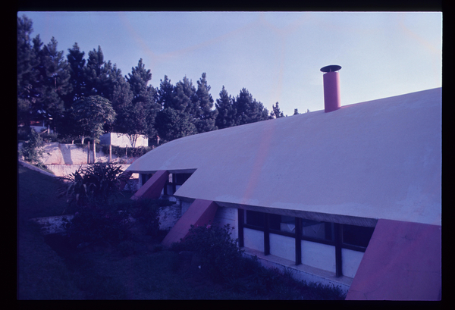

Ferro and Lefèvre’s Bernardo Issler House (1961)

Source: Archives, FAU USP library

<http://www.arquigrafia.org.br/photo/1993;jsessionid=04D85F02BD6F231EA53CA6918C21BBBB>

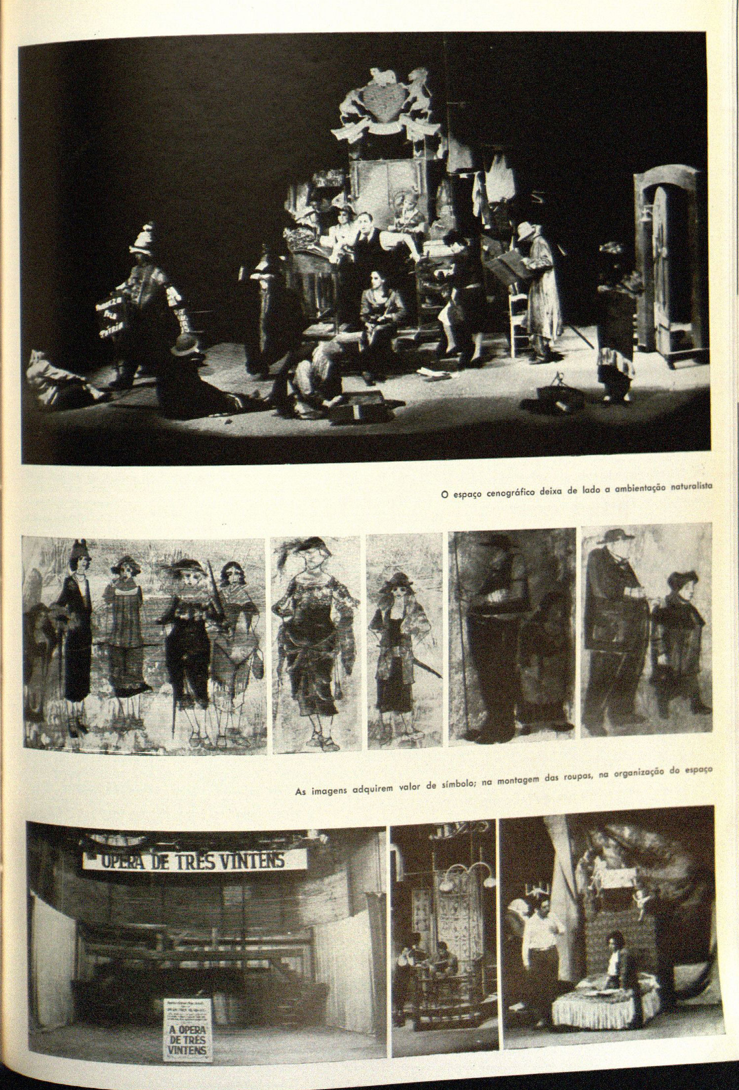

Império’s scenography for “Opera dos Três Vinténs” (1965)

Source: *Acrópole*, no. 319 (1965)

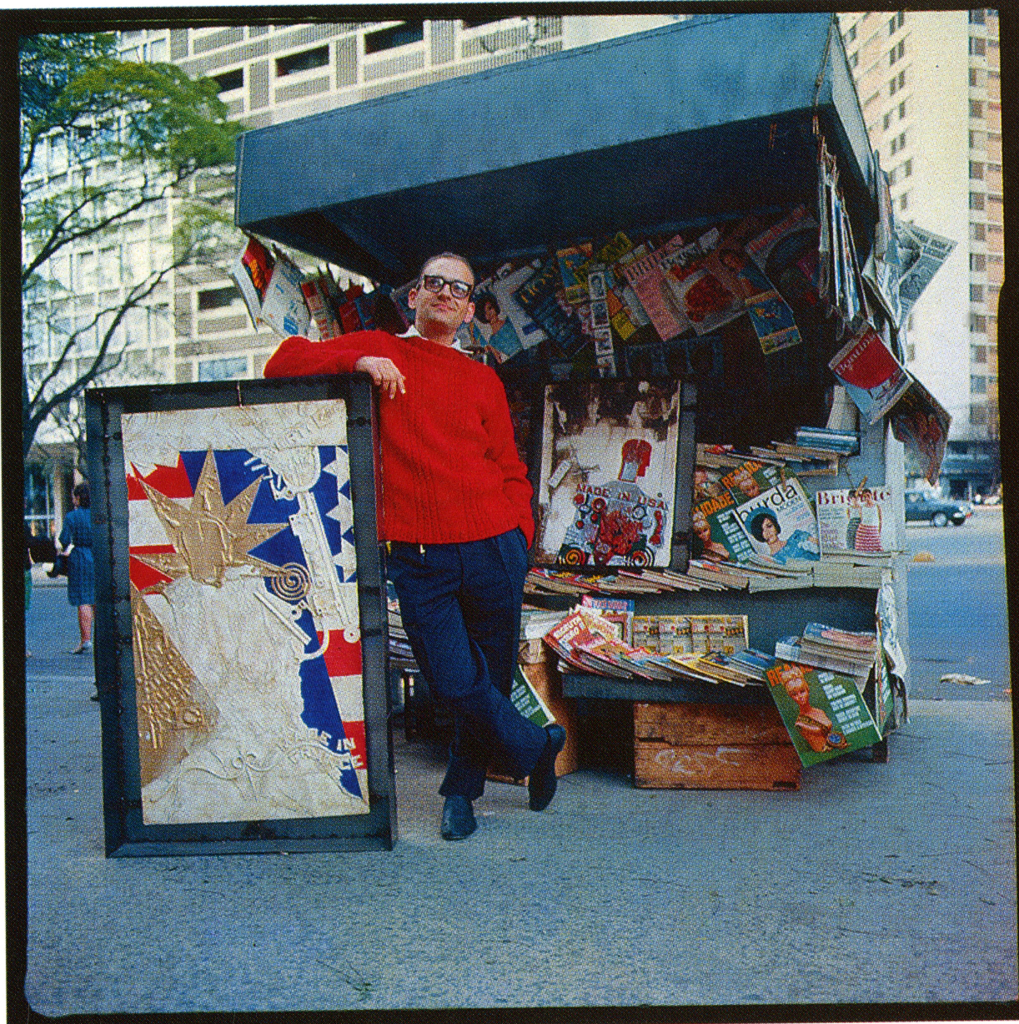

Flávio Império in 1966 with two of his “new paintings” entitled “Pena que ela seja uma...” and “Made in USA [72]”

Source: Renina Katz and Amélia Hamburger, ed. *Flávio Império*. São Paulo: Edusp, 1999.

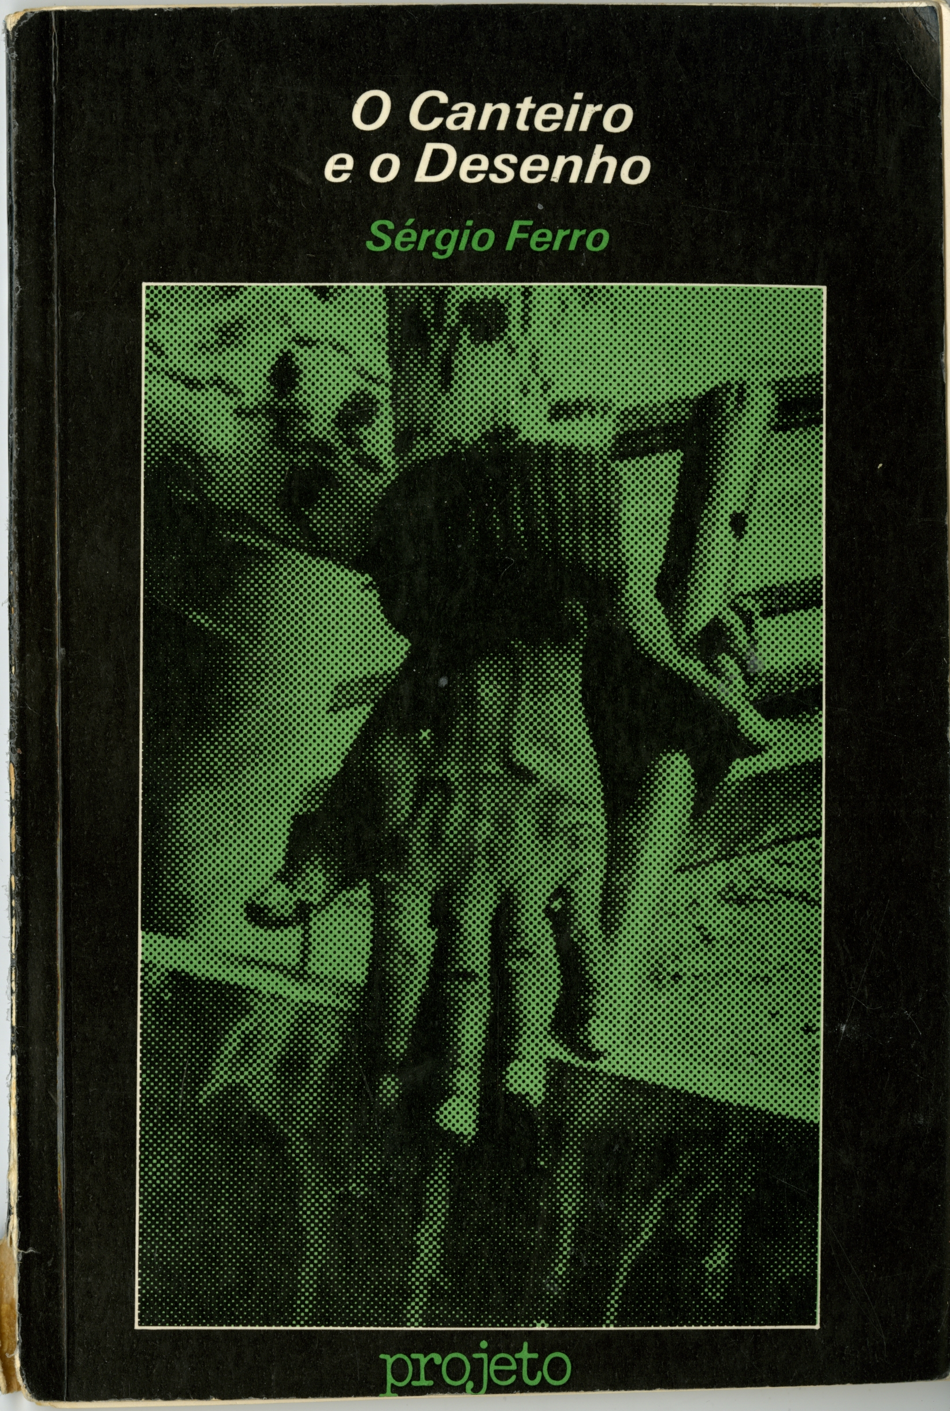

The cover of Ferro’s *O Canteiro e o desenho* (1982).

Photo Vanessa Grossman

1. Sérgio Ferro, “Arquitetura Nova,” *Teoria e Prática*, no. 1 (1967): 3-15.
2. Glauber Rocha, “Uma estética da fome,” *Revista Civilização Brasileira*, no. 3 (1965): 165-170 (All translations are my own, unless otherwise indicated).
3. Sérgio Ferro, “FAU, Travessa da Maria Antônia,” in *Maria Antônia: uma rua na contramão,* ed. Maria Cecília Loschiavo dos Santos (São Paulo: Nobel, 1988), 272.
4. Sérgio Ferro and Rodrigo Lefèvre, “Proposta inicial para um debate: possibilidade de atuação,” *Caderno Encontros* (1963). The article was reproduced in Pedro Fiori Arantes, ed., *Sérgio Ferro. Arquitetura e Trabalho Livre* (São Paulo: Cosac Naify, 2006), 33-36.
5. Sérgio Ferro, “FAU, Travessa da Maria Antônia,” op. cit., 272.
6. Sérgio Ferro, “Arquitetura Nova,” *Teoria e Prática*, no. 1 (1967): 3-15.
7. Glauber Rocha, “Uma estética da fome,” *Revista Civilização Brasileira*, no. 3 (1965): 165-170 (All translations are my own, unless otherwise indicated).
8. Sérgio Ferro, “FAU, Travessa da Maria Antônia,” in *Maria Antônia: uma rua na contramão,* ed. Maria Cecília Loschiavo dos Santos (São Paulo: Nobel, 1988), 272.
9. Sérgio Ferro and Rodrigo Lefèvre, “Proposta inicial para um debate: possibilidade de atuação,” *Caderno Encontros* (1963). The article was reproduced in Pedro Fiori Arantes, ed., *Sérgio Ferro. Arquitetura e Trabalho Livre* (São Paulo: Cosac Naify, 2006), 33-36.
10. Sérgio Ferro, “FAU, Travessa da Maria Antônia,” op. cit., 272.
11. Sérgio Ferro, interview by Marcelo Ridenti, in Marcelo Ridenti, *Em busca do povo brasileiro. Artistas da revolução, do CPC à era da TV* (Rio de Janeiro: Record, 2000), 96.
12. See Bruno Alfieri, “João Vilanova Artigas: ricerca brutalista,” *Zodiac*, no. 6 (1960): 96-107.
13. Sérgio Ferro, “Residência em Cotia,” *Acrópole*, no. 319 (1965): 38.
14. Sérgio Ferro quoted in Carlos Haag, “Quatro paredes mágicas,” *Pesquisa Fapesp,* no. 122 (2006), http://revistapesquisa.fapesp.br
15. With the addition of a short introduction, Ferro maintained a bi-partite structure corresponding to the two articles that preceded the book, published respectively in the second and third issues of the Brazilian journal *Almanaque.* They were entitled “A forma na arquitetura e o desenho da mercadoria” [“The form of architecture and the design of the commodity”] and “O desenho” [“The drawing”].